**App.js**

const express = require('express');

const mongoose = require('mongoose');

const app = express();

const port = 3000;

// MongoDB connection

mongoose.connect('mongodb://localhost:27017/myDatabase', { useNewUrlParser: true, useUnifiedTopology: true });

const db = mongoose.connection;

db.on('error', console.error.bind(console, 'MongoDB connection error:'));

db.once('open', function() {

    console.log('Connected to MongoDB...');

});

// Define a schema for your data

const Schema = mongoose.Schema;

const exampleSchema = new Schema({

    name: String,

    age: Number

});

// Create a model based on the schema

const Example = mongoose.model('Example', exampleSchema);

// Express middleware for parsing JSON bodies

app.use(express.json());

// Route to create a new example

app.post('/examples', async (req, res) => {

    try {

        const example = await Example.create(req.body);

        res.status(201).json(example);

    } catch (err) {

        res.status(400).json({ message: err.message });

    }

});

// Route to retrieve all examples

app.get('/examples', async (req, res) => {

    try {

        const examples = await Example.find();

        res.json(examples);

    } catch (err) {

        res.status(500).json({ message: err.message });

    }

});

// Route to retrieve a specific example by ID

app.get('/examples/:id', async (req, res) => {

    try {

        const example = await Example.findById(req.params.id);

        if (!example) {

            return res.status(404).json({ message: 'Example not found' });

        }

        res.json(example);

    } catch (err) {

        res.status(500).json({ message: err.message });

    }

});

// Route to update an example by ID

app.put('/examples/:id', async (req, res) => {

    try {

        const example = await Example.findByIdAndUpdate(req.params.id, req.body, { new: true });

        if (!example) {

            return res.status(404).json({ message: 'Example not found' });

        }

        res.json(example);

    } catch (err) {

        res.status(400).json({ message: err.message });

    }

});

// Route to delete an example by ID

app.delete('/examples/:id', async (req, res) => {

    try {

        const example = await Example.findByIdAndDelete(req.params.id);

        if (!example) {

            return res.status(404).json({ message: 'Example not found' });

        }

        res.json({ message: 'Example deleted successfully' });

    } catch (err) {

        res.status(500).json({ message: err.message });

    }

});

// Start the server

app.listen(port, () => {

    console.log(`Server is running on port ${port}`);

});

**Output:**

**Post Method:**

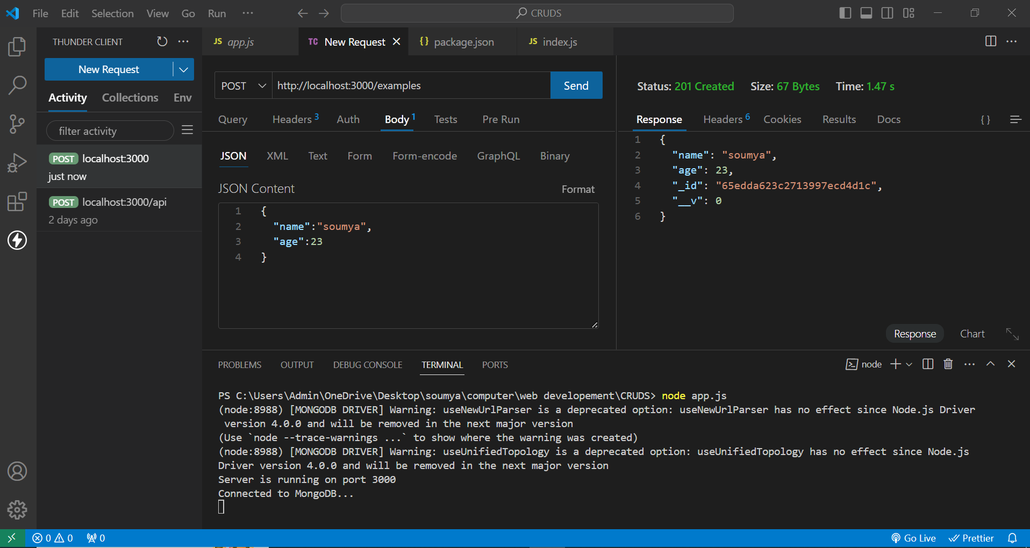

**Get Method:**

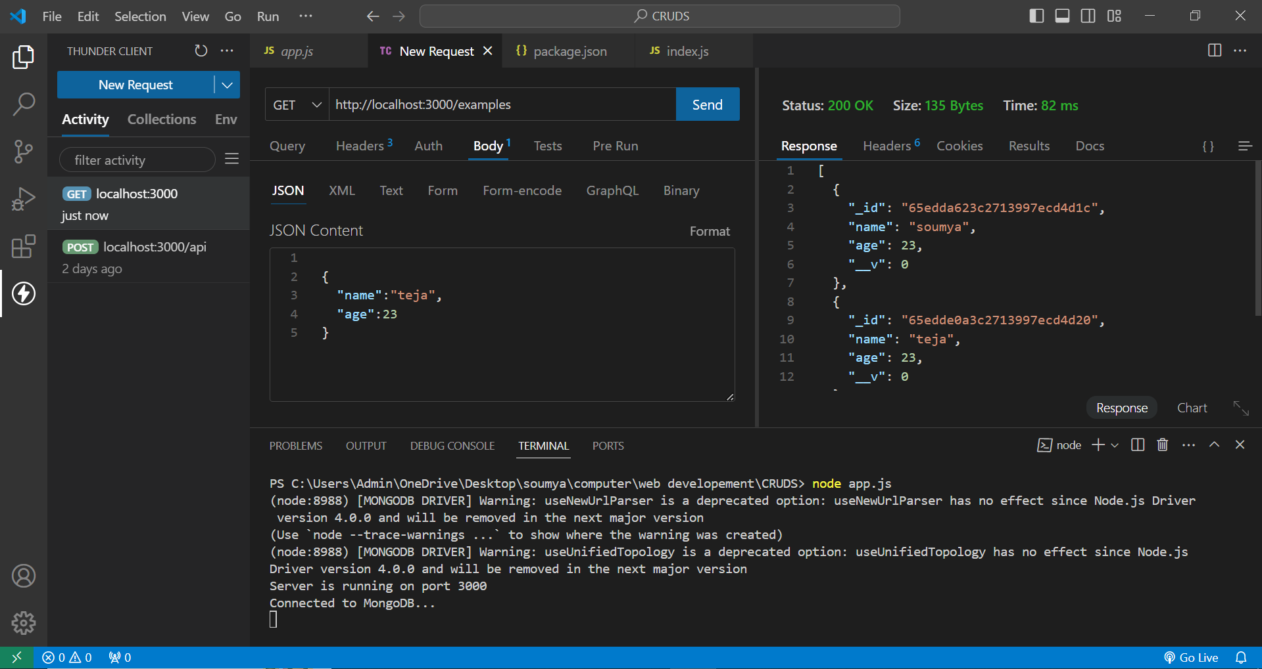

**Get Method by id:**

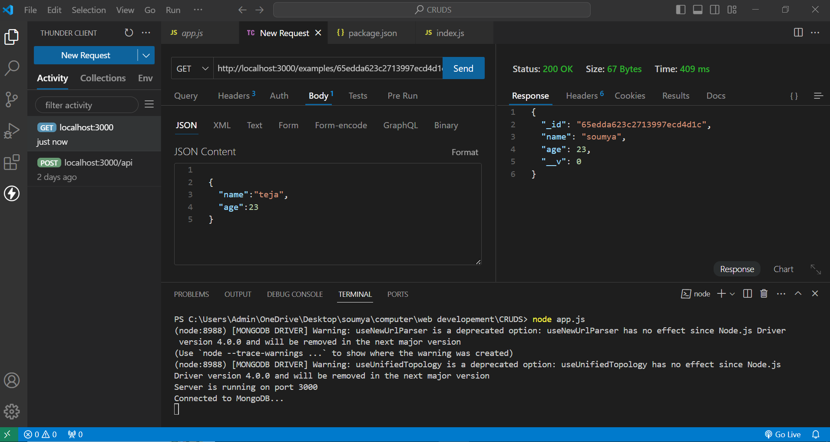

**Put(update) Method:**

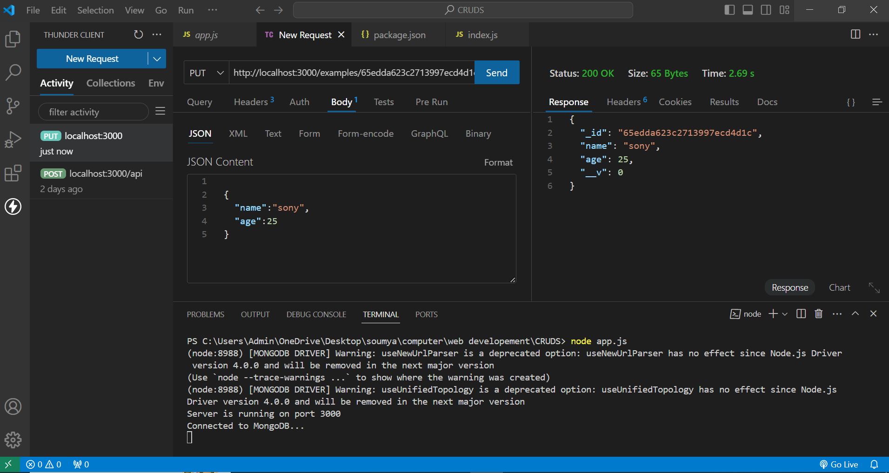

**Delete Method:**

